Physical Layer; class 2

10/09/2018

*Diapo : Physical Layer*

### 1/ Physical layer def

-> bits, tanslate

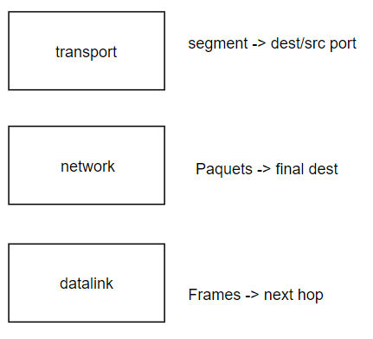

Why cables can support mega but not giga… Physical layer has limits due to the medium (the medium has physical limitations).

*How to optimise that?*

**key prob :** how to modulate data on physical mediums.

### 2 / Theoretical basis for data communication

different types of signals :

* with one amplitude, one frequency
* with different frequencies… => Harmonics : one main frequency, then multiple smaller ones *(representation : peigne de dirac*)

eg :

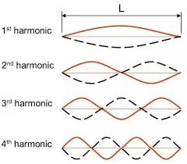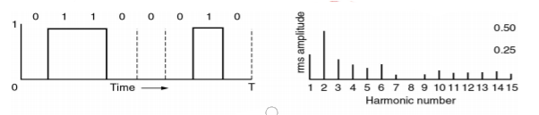

a regular signal has only one harmonic, a continuous one has several harmonics. The more harmonics the signal has the more precise it gets. It’s a sum of multiple frequencies

### 3/ Bandwidth

Bandwidth is one of the physical limits of the medium.

The less you have of bandwidth, the less you have harmonics. And the less you have harmonics, the less you have signals.

You have to find the good compromise so you can save max of the data

eg :

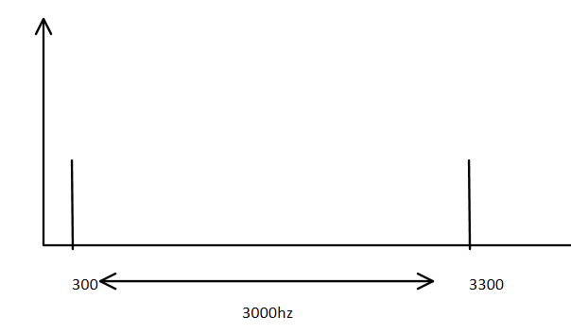

We can calculate the Baud rate of a signal :

R = 1 / detla

where delta is the symbol duration

delta = frequency / nb of harmonics

if b = 300 b/s

8/300*b/(b/s) = 8/300s

résultat : 37.5

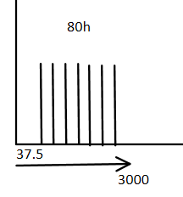

* for the same **frequency** you can have several **codes**.

**Symbols :** 0, 1 or a combination or both.

* Each **voltage** represent one **symbol**. It’s a way to optimize and maximize the physical media.
* It’s not perfect tho.

***Prob :*** if you don’t get a high enough number of voltage, the symbols will be too close to each other, and the machine won’t be able to read them.

* There’s always 2^n symbols.

### 4/ Max data rate of a channel

* max data rate depends of number of discrete symbols and the bandwidth
* V can’t go to infinity : distortion
* min number of V is 2.

**eg 2 :**

**bit rate** = D; **signal level** = V

-> use Shannon

Max rate = B * log2 ( 1 + S/N )

B = 1MHz = 1 000 000 Hz

S/N = 63

Max rate = 1000 * log2 ( 1 + 63 ) = 6 000 000 bits/s

-> use Nyquist

Max rate = 2 * B * log2(V) so log2(V) = 6 000 000 / B * 2 = 3

V = 2^( 3)

V=8

### 5/ Baseband transmission

* sends the data of all the bandwidths
* we can calculate the amplitude, frequency and phase

**The amplitude shift keying** use amplitude to modulate the data

**frequency shift keying** use different frequencies for different data

**Phrase shift keying** : same A, same frequency but different phases

eg : wireless data : 2.4GHz signal -> carrier signal, not the bandwidth

* we can have the mix of the 3 modulations in one formula :

### 

### 6/ more modems

b) you just change the amplitude & the frequency

### 7/ Line sharing

You have a large set of frequency. Each frequency carries data.

### 8/ TDMA

* you share resources over time

### 9/ Physical media